ASSIGNMENT 6-Python Basic-1 Solution

Submitted By: Sweta Dhara

Q.1. What are keywords in python? Using the keyword library, print all the python keywords.

A: Keywords are the reserved words in Python. We cannot use a keyword as a variable name, function name or any other identifier.

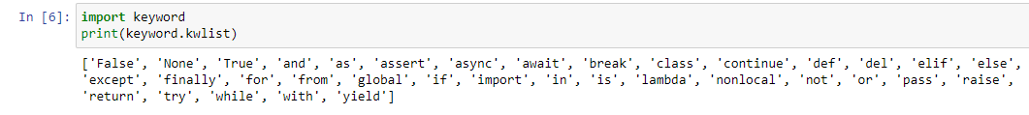

Q.2. What are the rules to create variables in python?

A: Rules for Python variables:

* A variable name must start with a letter or the underscore character
* A variable name cannot start with a number
* A variable name can only contain alpha-numeric characters and underscores (A-z, 0-9, and _ )
* Variable names are case-sensitive (age, Age and AGE are three different variables)

Q.3. What are the standards and conventions followed for the nomenclature of variables in python to improve code readability and maintainability?

A: The conventions is: Use grammatically correct variable names, the class name should start with an uppercase and must follow camelCase convention If more than two words are to be used. In the same way, a function name should be joined with an underscore, and it must be lowercase

Q.4. What will happen if a keyword is used as a variable name?

A: Keywords are reserve words in Python, so we cannot use them as variable names. It would be very hard to tell (for the developers and the compilers) whether something was a variable or a keyword.

Q.5. For what purpose def keyword is used?

A: def keyword in python is used to define a function. It is placed before a function name that is provided by the user to create a user-defined function.

Q.6. What is the operation of this special character ‘\’?

A: In Python strings, the backslash "\" is a special character, also called the "escape" character. It is used in representing certain whitespace characters: "\t" is a tab, "\n" is a newline, and "\r" is a carriage return.

Q.7. Give an example of the following conditions:

(i) Homogeneous list

(ii) Heterogeneous set

(iii) Homogeneous tuple

A: (i) Homogeneous list-

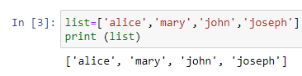

(ii) Heterogeneous set-

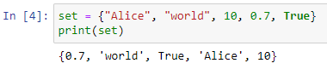

(iii) Homogeneous tuple-

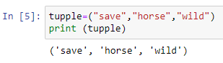

Q.8. Explain the mutable and immutable data types with proper explanation & examples.

Mutable data types in Python are those whose value can be changed in place after they have been created. In mutable data types, we can modify the already existing values of the data types (such as lists, dictionaries, etc.). Or, we may add new values or remove the existing values from our [data types](https://www.scaler.com/topics/data-types-in-python/). Basically, we may perform any operation with our data without having to create a new copy of our data type. Hence, the value assigned to any variable can be changed. Examples are: List, Dictionary, Set.

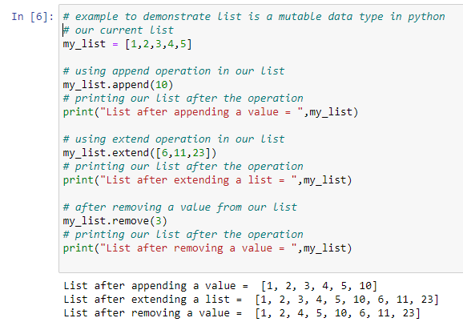

Immutable data types are those, whose values cannot be modified once they are created. Examples of immutable data types are int, str, [bool](https://www.scaler.com/topics/bool-in-python/), float, tuple, etc. Immutable types are preferred whenever we have data of some constant size.

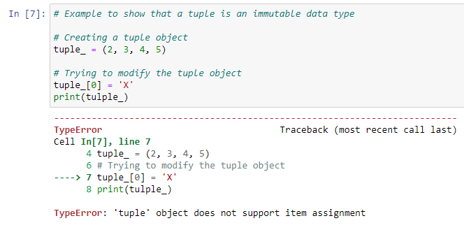

Q.9. Write a code to create the given structure using only for loop.

*

***

*****

*******

*********

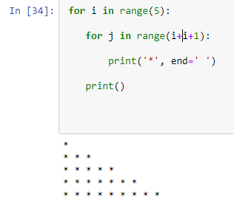

Q.10. Write a code to create the given structure using while loop.

|||||||||

|||||||

|||||

|||

|

A: 